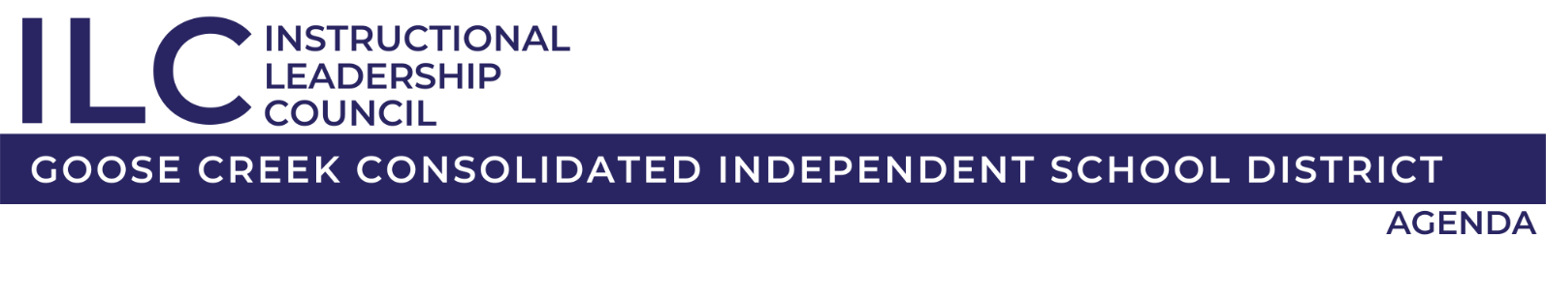
November 19, 2025
4:30 p.m. – 5:30 p.m.
Virtual
- Welcome
Dr. Susan Jackson

- DOI Phase-Out Plan
Dr. Matt Bolinger and Brooke Bingham

- RLA Instructional Framework Update
Dr. Sara Lawrence

- RLA & Math C&P Update
Dr. Sara Lawrence & Amy Henderson

- Adjourn

